Student Name | Charles Meredith
Activity Type | Cloud Computing and Cryptography Lab

Instructions
Perform the labs per the instructions in the iLabs environment.
- As you complete the tasks in the lab, insert a screenshot of the steps indicated below.
- Screenshots should contain unique information generated within the VM; this should include a shell (Bash in Linux, or PowerShell in Windows) with the output of the date command and your username typed below.
- Perform all the tasks shown below. Only provide screenshots for the tasks that specify a screenshot.

Tasks and Screenshots
Complete the following lab tasks in the Cloud Computing iLab Module:

- Lab 1 – Perform Reconnaissance on Azure
  - Task 1 – Azure Reconnaissance with AADInternals
    - Screenshot step 20
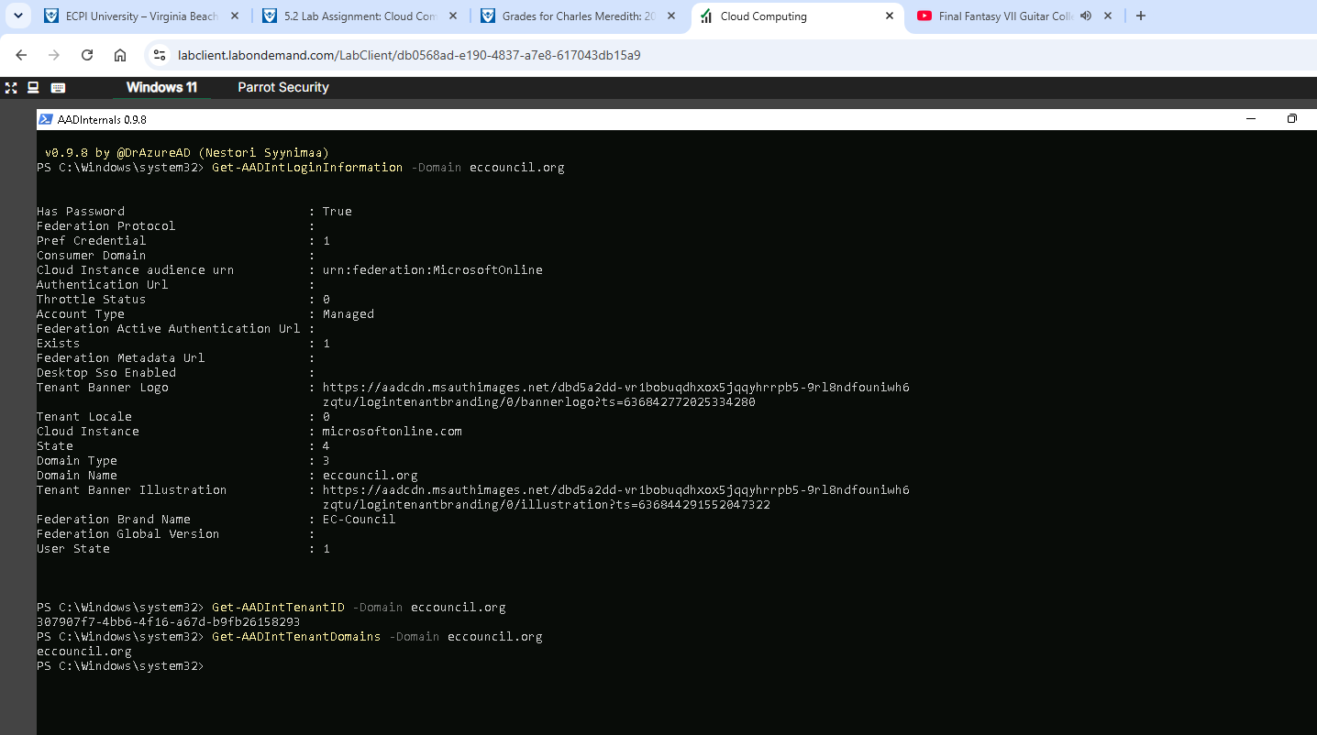

- Lab 2 – Exploit S3 Buckets
  - Task 1 – Exploit Open S3 Buckets using ASW CLI
    - Screenshot step 25
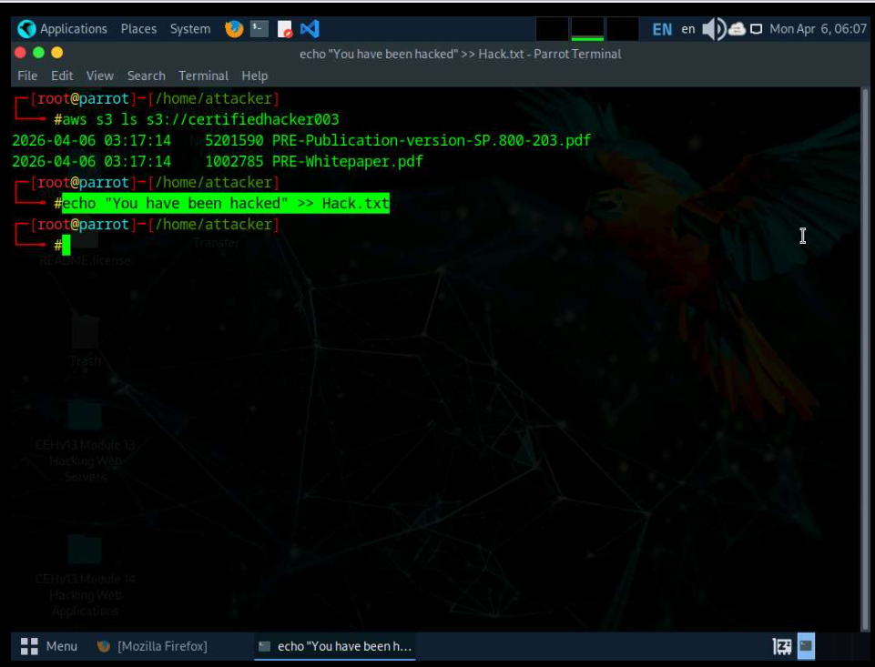

- Lab 3 – Perform Privilege Escalation to gain Higher Privileges
  - Task 1 – Escalate IAM User Privileges by Exploiting Misconfigured User Policy
    - Screenshot step 14
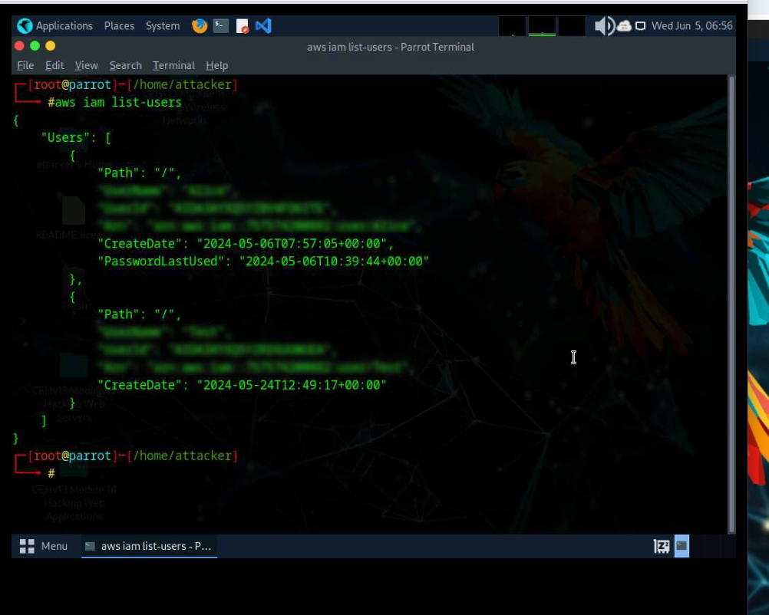
- Lab 4– Perform Vulnerability Assessment on Docker Images
  - Task 1 – Vulnerability Assessment on Docker Images using Trivy
    - Screenshot step 9
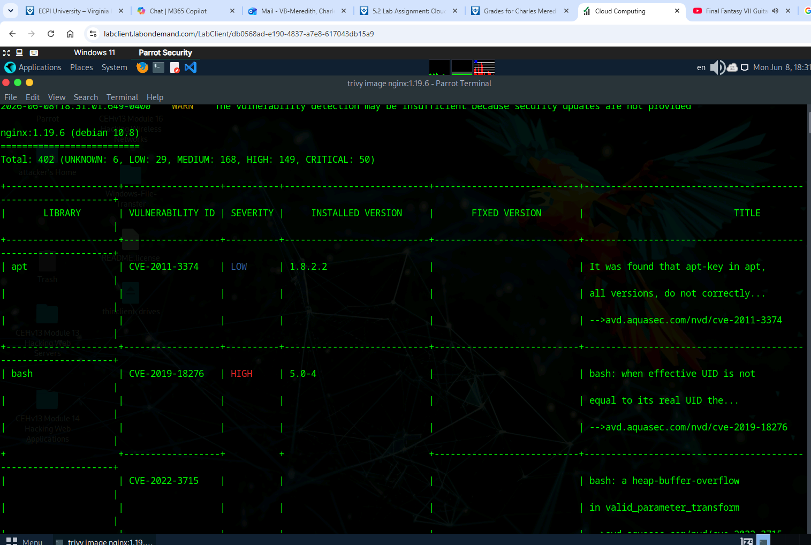
Complete the following lab tasks in the Cryptography iLab Module:

- Lab 1 - Encrypt the information using various Cryptography Tools
  - Task 1 - Encrypt and decrypt data using BCTextEncoder
    - Screenshot step 23
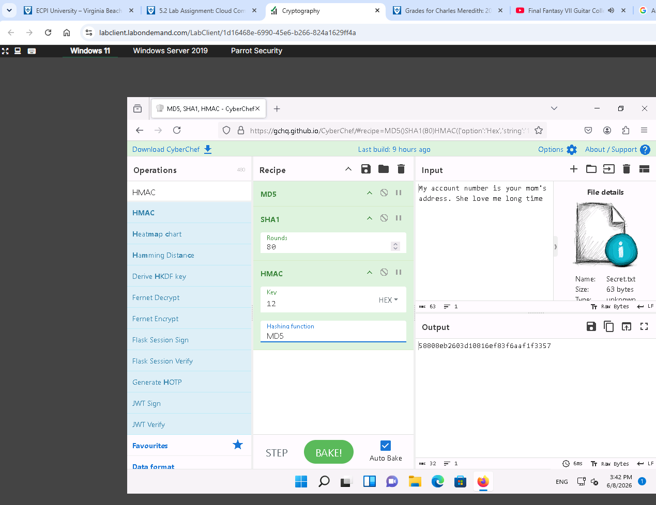
- Lab 2 - Create a Self-Signed Certificate
  - Task 1 – Create and Use Self-signed Certificates
    - Screenshot step 23
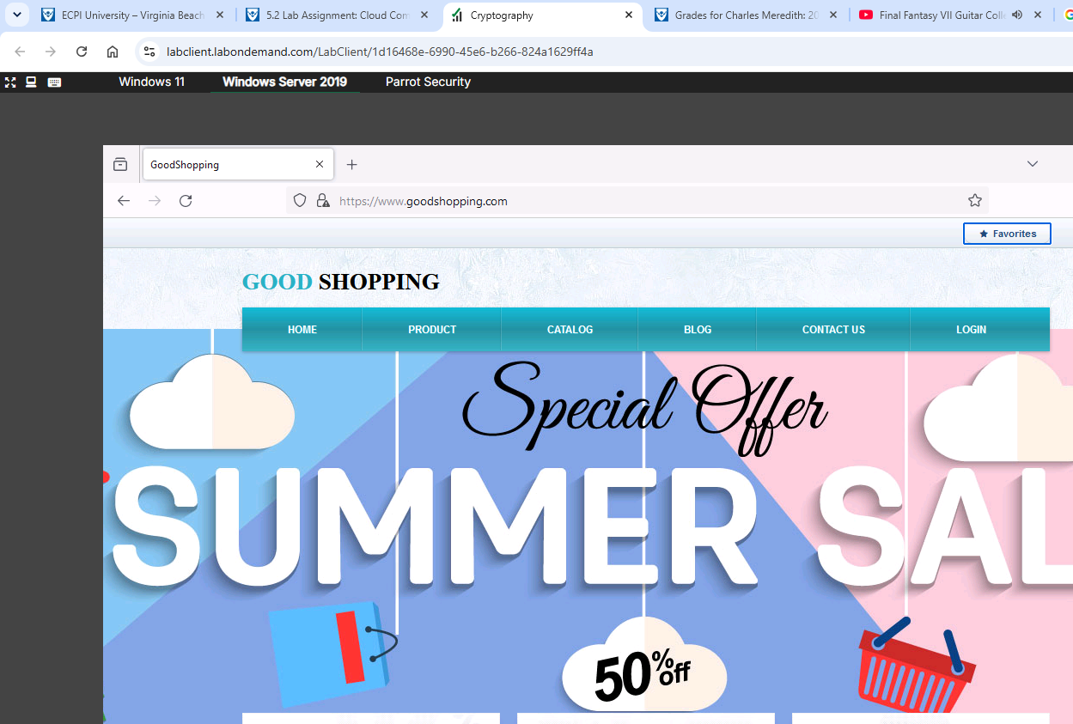

- Lab 3- Perform disk encryption
  - Task 1 - Perform disk encryption using VeraCrypt
    - Screenshot step 23
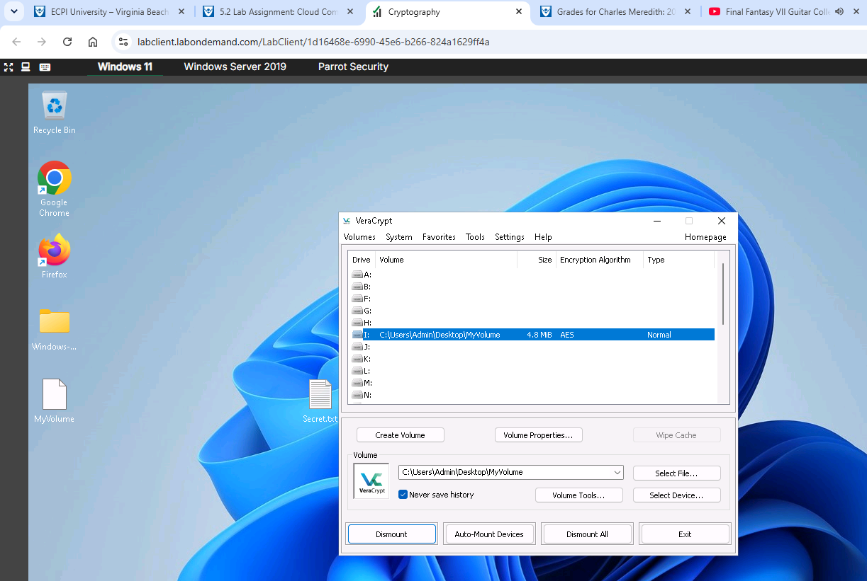
- Lab 4 - Perform Cryptography using AI
    - Screenshot step 7
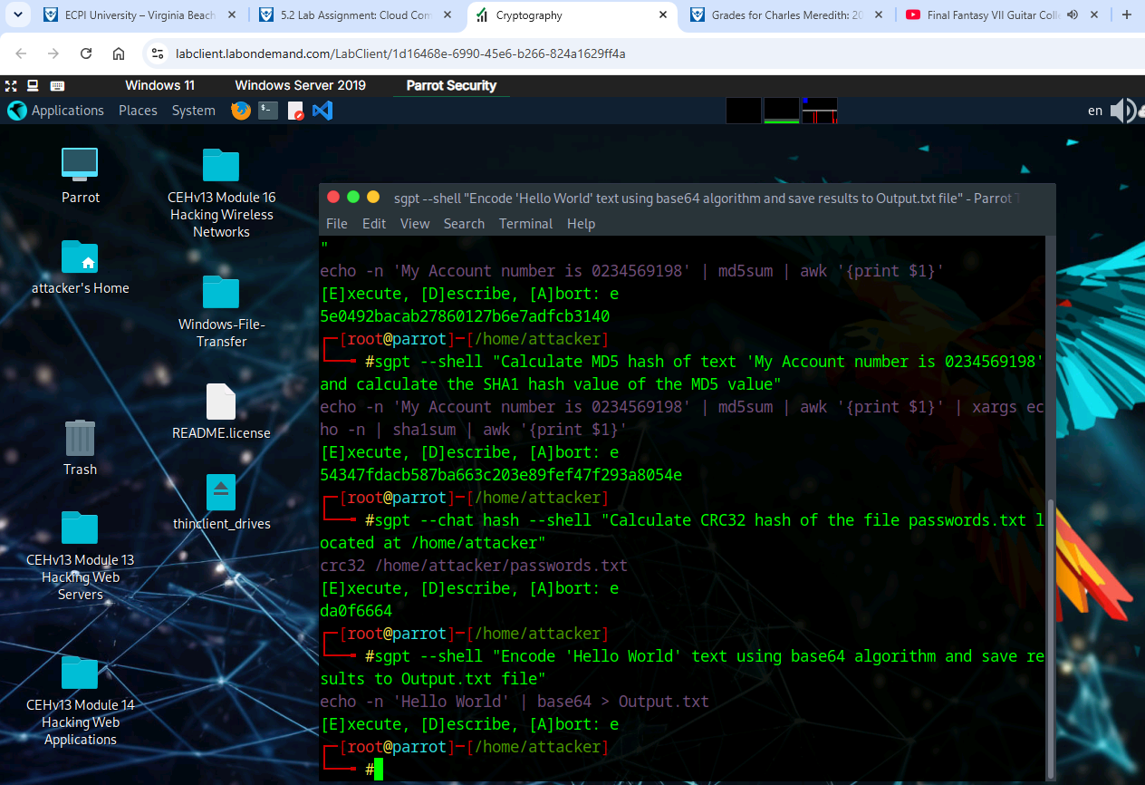
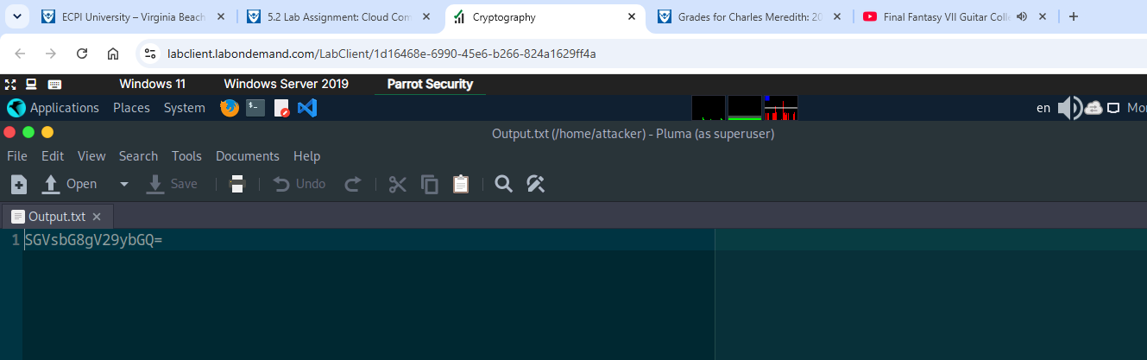

Summary
Write a few paragraphs summarizing the key skills you have acquired during this lab.

In this lab many skills were ascertained. For example, we used AAD Internals to gather information about Azure Cloud tenants and resources. We also used AWS CLI to interact with and exploit AWS S3 Buckets. Another tool and skill gained during this lab was using Trivy to scan pulled Docker images that may have vulnerabilities/exploits and what they are, their severity and mitigations strategies.
For the second lab we also learned many new skills. For example, in the first lab we used BC Text Encoder to encrypt and decrypt messages sent on a system or between shared resources. We also used VeraCrypt to mount, encrypt and add volumes to certain partitions or hard drives on a computer system. On the second to last lab, we created our own self-signed digital certificates to bypass or enable access to non-reachable websites. And for the last lab we used generative Shell GPT tools to aggregate all previous engagements techniques and streamline them and output contents of hashing information into an Output file.

Review Questions
Answer the following questions.
1. Security administrators claim that cloud systems are more vulnerable to Denial-of-Service Attacks, because they involve numerous individuals or clients, making DoS assaults potentially very harmful.
2. This tool has several features such as user enumeration, credential extraction, token extraction and
manipulation, privilege escalation, etc. AADInternals
3. This technique uses search engines such as Bing to perform reverse IP search to identify the domains of
the target S3 buckets. Reverse IP Search
4. A horizontal escalation is when an unauthorized user tries to access the resources, functions, and other
privileges of an authorized user who has similar access permissions
5. Containers or Docker Images are lightweight, standalone, executable packages that contain everything needed to run a software application, including the code, runtime, libraries, and dependencies.
6. Cryptography enables one to secure transactions, communications, and other processes performed in the
electronic world, and is additionally used to protect confidential data such as email messages, chat
sessions, web transactions, personal data, corporate data, e-commerce applications, etc.
7. Cryptography tools are used to convert the information present in plain text (readable format) into Cipher Text using a key or encryption scheme.
8. In Self Signed Certificates, a user creates a pair of public and private keys using a certificate creation tool
such as Adobe Acrobat Reader, Java's key tool, Apple's Keychain, etc. and signs the document with the
public key.
9. Disk Encryption provides confidentiality and privacy using passphrases and hidden volumes.
10. AI enhances cryptography with Encryption Algorithms such as AES, RSA, and quantum-resistant
methods.

